CSE341 Lab Quiz 5, 6
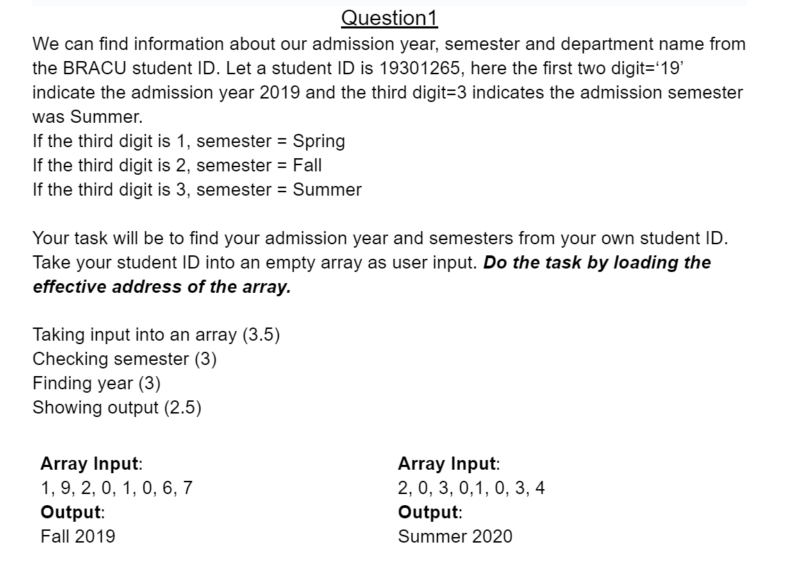

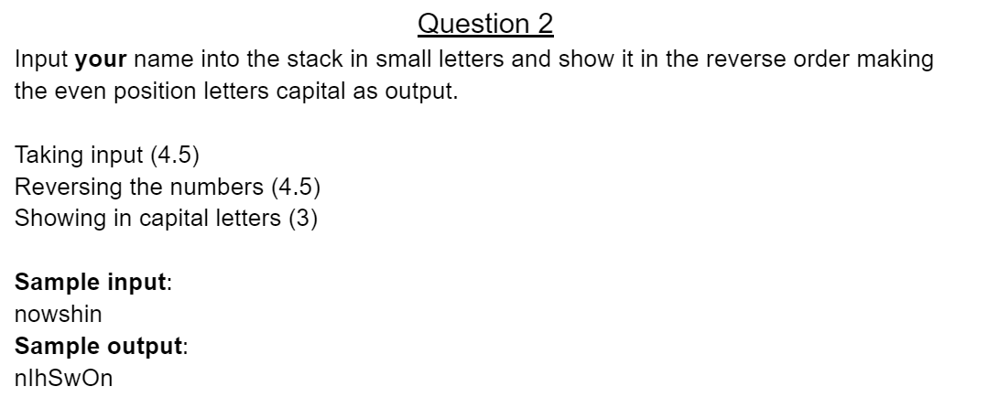

Submission Instructions:
- Copy and paste your answers into a single word/doc file.
- Rename the file into StudentID_Section, e.g. 21359173_01.
Submission Link: https://forms.gle/PvsyzerQtB6SFC4TA

